Kaimes School

Standards and Quality Report

Context of the School

Kaimes School is a school for children and young people who have complex, long term additional support needs where the presumption of mainstream cannot be met. All learners in Kaimes have a diagnosis of Autism. There is a maximum class size of 6 learners in each of our 16 classes. The usual support per class is 1 teacher and 1 member of support staff. Kaimes currently supports learners in both primary and secondary stages, however, the majority of pupils are of secondary age. Although located in the South-East area of Edinburgh, Kaimes School supports learners from across the city. School places at Kaimes are determined through the Education Resource Group (ERG).

The Vision for Kaimes School was reimagined by the school community during Session 22/23, reflecting our school community and aspirations for the future.

Kaimes mission is to be the best school for autistic learners in Scotland.

We do this by:
- Keeping children and young people at the centre of our decision making
- Working alongside a range of partners to provide exciting opportunities to improve outcomes for learners.
- Engaging with critical research and innovative thinking in autism and education to ensure that staff are best skilled.
- Delivering high quality teaching and purposeful learning to raise attainment and achievement.
- Creating a positive, inclusive and collaborative ethos where everyone feels valued and happy to come to Kaimes
- Celebrating each person for their uniqueness and achievements

We measure this through:
- Continuous self-evaluation and improvement
- Programme of robust quality assurance
- Improved attainment and achievement
- Regular consultation and engagement with all stakeholders
- Positive and sustained destinations

Our actions and improvements are guided by our core values:

AMBITION | We have high expectations for each member of our Kaimes community. We want everyone to participate, develop and achieve.
RESPECT | We respect everyone for who they are. This builds feelings of trust, safety and wellbeing.
TEAMWORK | By utilising our individual skills and abilities, we work together and learn together so that every child or young person can succeed in life.
INDEPENDENCE | Our children and young people develop skills and confidence to allow them to be as independent as possible in life.

Staffing
Headteacher (Acting) | Rob Greenaway
Depute Head Teachers | Irene McGinnis
Principal Teachers | Stephen Chester  Katie Mackenzie (Acting from April 2023)  Sandy Patterson
Business Manager | Jonathan Combe

The school is budgeted to employ 22.22fte teachers, 3.65fte Nursery Nurses, 19.34fte Pupil Support Assistants and 0.77fte Admin Support.
Retention of existing staff across the school has been strong and continues to improve from previous sessions, reflecting an improved culture and ethos.

Curriculum
The curriculum at Kaimes is flexible and adapted to suit the needs of learners. There is a clear focus on preparing the young people for life after school by developing skills across the curriculum. As all learners in Kaimes have Autism, there is an ongoing priority on the development of social communication skills and the tools for emotional regulation.
Learners benefit from working with a range of specialists up to the end of S3. These include Art, PE, Home Economics, Music and Science. Senior Phase pupils are able to build on their skills and interests by selecting are range of subjects and courses for certificated study.

Kaimes benefits from having access to two City of Edinburgh Council minibuses. These are used to support the wider curriculum and development of life skills. This allows our learners to develop skills within the community and make learning meaningful and relevant. Our wider curriculum this year has included Forest Schools, Duke of Edinburgh Award, Rock Climbing, Parkour, Paddleboarding, horse riding, skiing and swimming.

Standard and Quality Report 2023-2024

What have we done? | How well are you doing?  What’s working well for your learners? | How do you know?  What evidence do you have of positive impact on learners? | What are you going to do now?  What are your improvement priorities in this area? | How would you evaluate this QI using the HGIOS?4/HGIOELC? six-point scale?
QI 1.3 Leadership of change (Developing a shared vision, values and aims relevant to the school and its community; Strategic planning for continuous
improvement; Implementing improvement and change)
Revised Vision and Value statements are regularly revisited and inform all decision making and future school improvement planning.  Base Class Model is now fully embedded/established across the school.  Review of leadership roles and operational and strategic responsibilities across SLT  Introduction of QA and Risk Assurance calendar  June Timetable change implemented to support transition of pupils and ensure alignment with other CEC  Conducted school Team Stress Risk Assessment to inform next steps for operational and strategic planning.  Introduction of weekly HT communication to all staff to inform of school decision making, operational items and impending deadlines.  Introduction of monthly HT meetings with Support Staff | - A majority of pupils show an understanding of the school’s vision. Visuals are prominent throughout the school building/website and are regularly revisited during school assemblies.  - Increased whole school attainment across the senior phase supported through Base Class model. This has resulted in more pupils achieving full SQA courses within the senior phase.  - Move to 1 x DHT and 3 x PSL and introduction of weekly meetings with HT to discuss caseload and strategic responsibilities and/or planning.  - Move to June change of timetable. Learner’s transitions are better supported through timely and informed decision making prior to the summer holiday.  - Feedback from most support staff has been positive in relation to the frequency of pupil updates and better whole school communication.  - Feedback from the Team Stress Risk Assessment highlighted a number of areas for development in relation to culture, support, demands and relationships across all roles. | - Positive feedback from staff, parents/carers, and learners regarding the updated vision, values, and aims.  - Increase in requests for family/school tours of Kaimes and placing requests through ERG, evidencing a shifting -positive -change in the external profile of the school.  - Reduction in period truancy and fewer incidents of dysregulated learners reported  - Reduced number of issues/incidents attributed to change of timetable  - Improved attainment and achievement data, 3x increase in full SQA courses achieved by young people from previous session  - Improved attendance and reduction in flexible timetables | - Develop a menu of professional development opportunities for teaching staff alongside QIEO & ASL/Ed Psych/EL services to further enhance skills & knowledge relating to Base class delivery as part of Inservice/CAT programme. Options for both primary and secondary trained colleagues to include:  -Circle Inclusive Classroom  -EL Achievement of a level  -SQA procedures/verification  -Leading Literacy  -Leading Numeracy  -Delivering WB entitlement  -Writing IEP’s  -Formative Assessment  -Using Data to plan learning  - All colleagues to engage with Edinburgh Teachers Charter Professional learning offer supported through WTA.  - Reduce PSL’s class contact time to provide sufficient time for case load, line management and strategic responsibilities.  - Introduction of annual attainment meetings for all Base class teachers and Subject Specialists to review attainment.  - Review of PRD policy and link to new LT&A policy. Create sufficient- inbuilt -opportunities for Support staff to engage in meaningful professional learning opportunities identified through PRD.  - Involve learners, parents/carers, and the wider community in the ongoing review of the school improvement plan, ensuring that it remains responsive to the evolving needs of the school community.  - Foster a culture of continuous improvement, where all members of the school community feel empowered to contribute to positive change. | Satisfactory
QI 2.3 Learning, teaching and assessment (Learning and engagement; Quality of teaching; Effective use of assessment; Planning, tracking and monitoring)
SCERTS Appreciative Enquiry rounds introduced to support sharing of practice.  Short life Tracking and Monitoring group established to identify key measures for effective TM&R across school.  Co-construction of a new Learning, Teaching and Assessment Policy to be implemented session 24/25 | - Feedback from Teaching staff on the Appreciative Enquiry round called for more structure and clarity of observation focus during rounds. Most felt that the opportunity should evolve to better support the development of practice  - Key measures identified to support and capture progress in learning – across all levels – to be included in new TM system planned for session 24-25. SQA Verification systems are evident across the senior phase, however, there are currently limited inbuilt opportunities to moderate levels within the BGE supported through the WTA.  - A majority of learners feel that learning is appropriately challenging.  - Feedback from colleagues and learners identified that the current Pupil Support Framework policy was not readily identifiable or sufficiently embedded within the life and work of the school and required updating.  Stakeholders’ (staff, pupils, and parent council) contributed to the co-construction of an infographic of what ‘What Great Teaching at Kaimes looks like’. Feedback from various sessions has been overwhelmingly positive, commenting on the clarity and accessibility of the infographic.  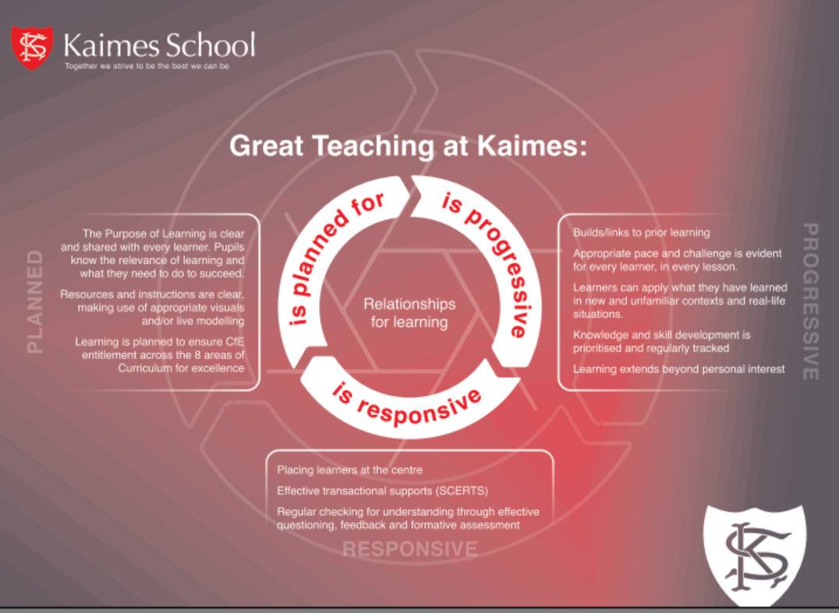 | - Staff feedback on Appreciative Enquiry rounds  - Feedback from various rounds of consultation relating to the key features of effective LT&A at Kaimes.  - Feedback from staff on current levels of engagement with Edinburgh Teacher Charter and ‘What great Teaching’ should look like at Kaimes.  - Review of current data relating to learning and progress tracked across the school.  - Review of WTA session 23/24 and time allocated to moderation activities | - Introduction- and full implementation- of school wide Tracking and Monitoring system at Kaimes.  - Appreciative rounds to be replaced with an SCE model and extended to 2 rounds per session. Observation focus will center on ‘What Great Teaching looks like’ at Kaimes’ infographic. Mechanism to be developed to support feedback from SCE observations to the wider school– used to inform future professional learning opportunities, self-evaluation activities and SIP  - As part of the in-house professional learning offer for session 24/25, teaching staff will engage with EL Achievement of a Level CLPL to further support work undertaken in consistent professional teacher judgements being made.  - School will participate in moderation of a level activities alongside the Learning Community during session 24/25 as well as in house opportunities for moderation.  - New LT&A policy to be fully drafted, this will be framed on the infographic ‘What Great Teaching Looks Like’  - All staff to engage fully with data in relation to their pupils to inform next steps, progression and challenge for all learners.  - Using data from the new tracking system - cohorts to be identified to ensure gaps in learning are being addressed through the planning and delivery of well-considered, timely interventions. | Weak
QI 3.1 Ensuring wellbeing, equality and inclusion (Wellbeing; Fulfilment of statutory duties; Inclusion and equality)
- Co-construction of Relationships for learning policy  - Introduction of House System  - Creation of PSO role (family engagement and attendance)  - All teaching staff have engaged with the Autism training delivered in partnership with Strathclyde University. Support staff engaged with 1 day of full training during August Inservice. | Review of the current Pupil Support Framework policy through a short life working group highlighted that the policy was not readily identifiable or sufficiently embedded within the life and work of the school and in need of renewal. Stakeholders’ (staff, pupils, and parent council) contributed to the co-construction of a Relationship for learning infographic. Feedback from various sessions has been overwhelmingly positive, commenting on the clarity and accessibility of the infographic.  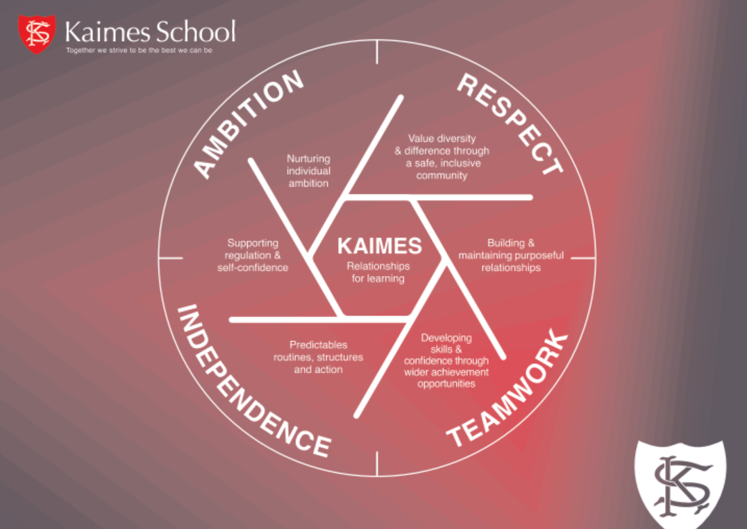  - Following pupil consultation, a school House System Introduced to support House Identity and improve school culture. Initial feedback from pupils has been positive, evidenced by the number of House points awarded following its introduction.  - Introduction of PSO role has had a positive effect on pupils with low attendance. Number of outreach sessions have increased and have been supportive in returning pupils back to school  - Family engagement event was well attended by partner agencies and families. Almost all in attendance spoke positively about the event.  - Almost all staff have demonstrated a clearer understanding of barriers to learning relating to Autism (PDA, Autistic Trauma and parental engagement) as a result of Strathclyde input | - Feedback from Child Planning Meetings indicate that families feel supported.  - Attendance statistics show an improving trend for almost all targeted families.  - Number of House points awarded.  - Average school attendance figures have increased  - Feedback from staff on the University of Strathclyde sessions. | - Introduction of parent/carer survey  - Creation of new Relationships for Learning policy to include CEC Behaviour of Concerns to be implemented during session 23/24  - Track progress in learning and achievement for care experienced young people and those living in poverty.  - Continue to embed children’s rights across all aspects of our work.  - Wellbeing Curriculum Working group to be established session 24/25 to create a whole school HWB curriculum Framework and guidance to ensure pupil entitlement.  - PSO role to increase to fulltime session 24/25. Work to be extended to increase capacity of both ‘in reach’ and ‘outreach’ programmes to improve attendance and attainment. | Satisfactory
QI 3.2 Raising attainment and achievement (Attainment in literacy and numeracy; Attainment over time; Overall quality of learners’ achievement; Equity for all learners)
- Implementation of SQA procedures to regularly review progress and attainment of level (Including verification activities both in with and out with the school).  - Improvements in Senior Phase curricular offer to ensure flexibility, challenge and choice for all learners | Attainment Over Time  - Improved attainment and achievement data, 3x increase in full SQA courses achieved by young people from previous session (10 x increase since 2018)  Overall Quality of Learners’ Achievement  - Pupils’ engagement and achievement within the DofE programme (Bronze and Silver) has increased during session 23/24.  - Pupils’ engagement with Work Experience placements has led to a number of pupils achieving volunteering SQA units/awards  - Participation in Enterprise activities and awards.  Equity for all Learners  - All staff now have a much deeper understanding of the impact of Autism on wellbeing and attainment through engagement with University of Strathclyde professional learning offer. They are able to identify the impact of individual pupil barriers to attainment and plan interventions in a more responsive and creative way. | - Improved attainment data relating to pupils achieving full courses within the senior phase at both L2 and L3.  - Total number of learners achieving DofE Bronze/Silver awards | - Implement tracking system to ensure pupils are tracked at an individual level in Literacy and Numeracy.  - Increase opportunities for learners to achieve at SCQF level 4 and 5+ through the introduction of appropriate NPA’s  - Introduction of a Literacy, Numeracy and SQA Curriculum Working groups next session to produce framework documents to support delivery in respective areas of the curriculum.  - Plan opportunities at school, and learning community levels (at least 1 session), to engage in moderation activity focused on either Literacy or Numeracy  - Increase staff confidence in planning, assessing, and making judgments about pupil progress across all levels.  - Improved systems to identify individual learners who require targeted support for wider achievement, enabling tailored interventions to be planned and implemented.  - Improve overall arrangements for tracking individual pupils’ attainment over time with regular attainment meetings at key points throughout the year - aimed to support staff in making effective use of assessments, and developing their shared understanding of standards, to make confident professional judgements about pupils’ progress and attainment levels. | Satisfactory
QI 2.1 Safeguarding and Child Protection (Arrangements for safeguarding, including child protection; Arrangements to ensure wellbeing; National guidance and legislation)
- All staff participated in their annual CP update in August.  - Review of wellbeing concerns through PSL pupil meetings and QA calendar to identify patterns and highlight adjustments necessary within the curriculum.  - Number of CALM trained colleagues increased across school.  - Class Purple folders regularly reviewed including supportive documents such as RA and PCPI’s | - All staff are aware of safeguarding policies and procedures. They understand how to escalate any concerns.  - Wellbeing patterns and safeguarding issues are tracked as part of Pupil Caseload fortnightly meetings supporting both proactive and reactive interventions and decision making.  - Bullying and prejudice system within Seemis is now implemented to report all instances of bullying and/or discrimination.  - Capacity to respond in an appropriate and supportive way to incidents continues to improve due to number of CALM trained colleagues.  - Reduced number of physical interventions or seclusion required to safeguard dysregulated learners | - Checklist of all staff with up to date CP training.  - List of volunteers with PVGs checked.  - Tracked data relating to CALM  - List of CALM qualified staff (theory and practical)  - Updated and Quality assured Class Purple folders | - Review of safeguarding procedures in line with CEC updated guidance and update all staff on any changes.  - Review safeguarding record keeping systems to ensure they follow the updated CEC guidance.  - Explore partnership accreditation of CALM with other CEC special schools or authority to increase capacity for training or re-accreditation | Satisfactory
QI 2.2 Curriculum: Theme 3 Learning pathways
- Introduction of Activity Tourism and Rural Skills as part of the Senior phase curriculum alongside an enhanced BGE offer.  - Introduction of Construction Academy in partnership with Tigers programme session 24/25 | - Learners are engaged and motivated, with clear pathways that allow them to build on prior learning and develop new skills within Outdoor learning.  - A wide range of learning experiences are available through Outdoor learning offer – this supports learners to develop resilience, creativity, and critical thinking.  - Developing partnerships with external organisations and community partners enhance the curriculum and provide meaningful, real-life learning opportunities. | - Pupil uptake within Activity Tourism offer  - High levels of learner engagement and motivation, as evidenced by attendance, participation, and feedback in outdoor learning offer.  - Improved attainment and achievement within DofE programme  - Positive feedback from learners, parents/carers  - Successful partnerships with external organisations and community partners | - Introduction of SQA curriculum working group to explore further SCQF courses that could be introduced as part of the school’ senior phase offer. Group to focus on progression pathways leading to level 4 & 5 accreditation  - Review of Rural Skills, Activity Tourism and construction academy uptake and attainment session 24/25.  - Strengthen the monitoring and evaluation of the curriculum, using data and feedback to inform ongoing improvements.  - Continue to foster strong partnerships with external organisations and community partners, exploring new opportunities to enrich the curriculum and support learners' personal achievements.  - Provide ongoing professional development opportunities for staff, supporting them in delivering high-quality learning experiences across all learning pathways. | Satisfactory
QI 2.7 Partnerships: Theme 3 Impact on learners (parental engagement only)
- Regular parent-teacher meetings, sessions to support parents/carers in understanding their child's learning and development – including pupil diaries  - Continued to build our partnership work with the Parent Council, fostering a collaborative relationship between the school and parents/carers.  - Introduction of school Finance Committee  - Facilitated parent council representation on KSSA finance group  - Improved opportunities for parents/carers to volunteer and contribute to school events, activities, and projects. | - Established various channels of communication for parents/carers, such as social media, home-school diaries, to keep them informed and involved in school activities and decision-making processes.  - Learners benefit from a supportive and collaborative community, with parents/carers actively contributing to school events, activities, and projects.  - The Parent Council is now represented in both the school finance committee and KSSA finance committee to support full transparency | - High levels of parental engagement and satisfaction - evidenced by attendance at school events and information sessions.  - Positive feedback from learners, parents/carers, and staff regarding the impact of parental engagement on learners' experiences and success. | - Further enhance communication channels and strategies to ensure all parents/carers have timely access to relevant information and feel well-informed about their child's learning and development. This is to include introduction of Tracking and Monitoring system  - Establish a working group with parents to look at ways we can improve our ways of reporting children’s progress to parents.  - Develop additional opportunities for parents/carers to engage in their child's learning, including workshops, information sessions, and online resources.  - Strengthen the role of the Parent Council in representing the views and interests of parents/carers, ensuring that they have a meaningful impact on school decision-making and improvement planning | Satisfactory

